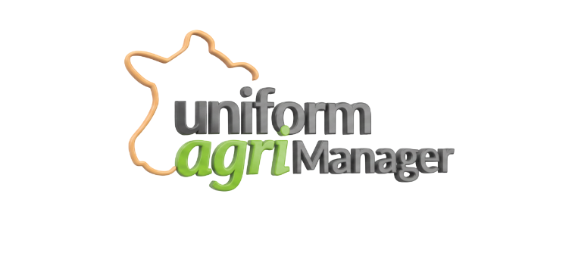
App Concept: A specialized ERP for Uniform-Agri dealers.
- Clients: Farm name, Contact, WhatsApp Link.
- Finance: Tracks the full loop of money between the farm, 4Genetics, and the HQ.
- Quoting: Dynamic pricing logic based on livestock species.
- Support: Ticketing system to identify the most "repeated" problems in Egyptian farms.
- The AI Edge: Integrated assistant for natural language data retrieval.

